|  |  |
| --- | --- |
| **NAME** | **Mohamed Abdullah.M** |
| **TEAM ID** | PNT2022TMID37442 |
| **PROJECT** | **IoT Based Safety Gadget for Child Safety Monitoring & Notification** |

**LITERATURE SURVEY**

The system is developed using Link-It ONE board programmed in embedded C and interfaced with temperature, heartbeat, touch sensors and also GPS, GSM & digital camera modules. The novelty of the work is that the system automatically alerts the parent/caretaker by sending SMS, when immediate attention is required for the child during emergency**.**

This paper proposed a model for child safety through smart phones that provides the option to track the location of their children as well as in case of emergency children is able to send a quick message and its current location via Short Message services

The purpose of this device is to help the parents to locate their children with ease. At the moment there are many wearable’s in the market which helps to track the daily activity of children and also helps to find the child using Wi-Fi and Bluetooth services present on the device.

The system is developed using Link-It ONE board programmed in embedded C and interfaced with temperature, heartbeat, touch sensors and also GPS, GSM & digital camera modules. The novelty of the work is that the system automatically alerts the parent/caretaker by sending SMS, when immediate attention is required for the child during emergency

The purpose of this device is to help the parents to locate their children with ease. At the moment there are many wearable’s in the market which helps to track the daily activity of children and also helps to find the child using smartphone is required and doesn’t want to be very tech savvy individual to operate

phone network signal/internet so that safety gadget can even be under monitoring when it reaches remote areas where communication signals is not reachable like forest. Safety gadget consists of BEACON and BLE packet is transmitted through it, this packet is received by binding gadget which has BLE (Bluetooth Low Energy) receiver module, the packet usually contains information such as identification number, signal strength etc. Whenever the packet is received it checks for all the above information in the receiver device.

As the distance between safety gadget and binding gadget increases, the signal strength decreases. Once the safety gadget is moving out of threshold distance from the binding gadget then an alert is provided on binding gadget which will be used by parent/guardian.

**MERITS**

* The parameters such as touch, temperature & heartbeat of the child are used for parametric analysis and results are plotted for the same.
* This wearable over other wearable is that it can be used in any phone and it is not necessary that an expensive Literature Survey
* The parameters such as touch, temperature & heartbeat of the child are used for parametric analysis and results are plotted for the same.
* The advantages of smart phones which offers rich features like Google maps, GPS, SMS etc.
* A child tracking system using android terminal and hoc networks

.

**DEMERITS**

* To implement the IoT device which ensures the complete solution for child safety problems.Child safety wearable device.
* To implement the IoT device which ensures the complete solution for child safety problems.Child safety wearable device.
* this device’s battery gives short life-time. High power efficient model will have to be used which can be capable of giving the battery life for a longer time
* This system is unable to sense human behavior of child
* This device cannot be used in rural areas.

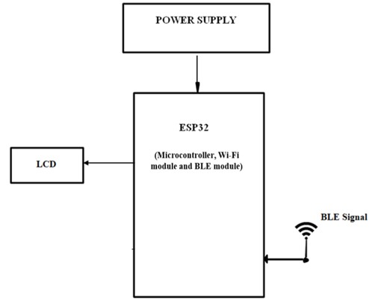

Block diagram of BLE listener device

**Tools Used Hardware Requirements***:*

* + Arduino Mega [ATMEGA 2560].
  + GSM SIM 800C.
  + GPS Neo 6m.
  + 20X4 LCD.
  + I2C LCD Driver
  + 7805 Voltage Regulator.
  + Heart Beat Sensor.
  + DS18B20 Temperature Sensor.
  + 1x4 Switch.
  + ESP8266-12E
  + Push Button
  + Logic Level Convertor
  + Buzzer
  + LED
  + ESP32
  + OLED
  + Jumper Cables

*Software Requirements:*

* + Arduino IDE
  + Android Studio

*Languages Used:*

* + Embedded C
  + Java